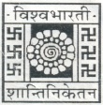
DEPARTMENT OF ODIA, VISVA-BHARATI
SANTINIKETAN – 731 235 (WEST-BENGAL)

Class Rooms with IT Facilities
The Department of Odia is equipped with two ICT-enabled classrooms designated for M.A. First and Second Year programmes. These smart classrooms facilitate regular teaching as well as blended and digital learning initiatives. The Second Year classroom additionally functions as a venue for online seminars, invited lectures, academic discourses, and cultural programmes.

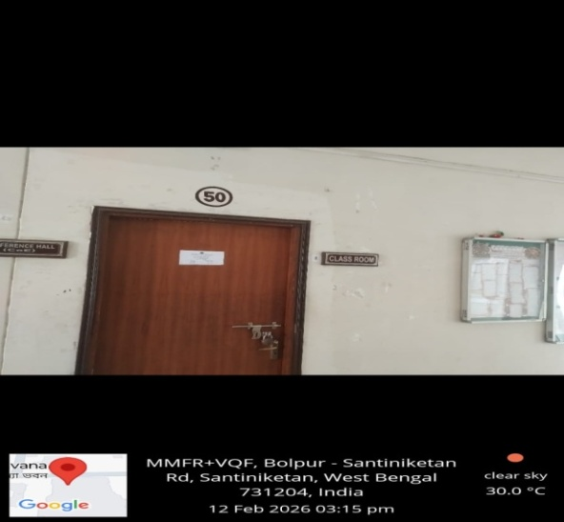

DEPARTMENT OF ODIA, VISVA-BHARATI
SANTINIKETAN – 731 235 (WEST-BENGAL)

Class Rooms with IT Facilities

The Museum space also serves as a dedicated classroom for Special Papers and research scholars and is supported by adequate ICT infrastructure.

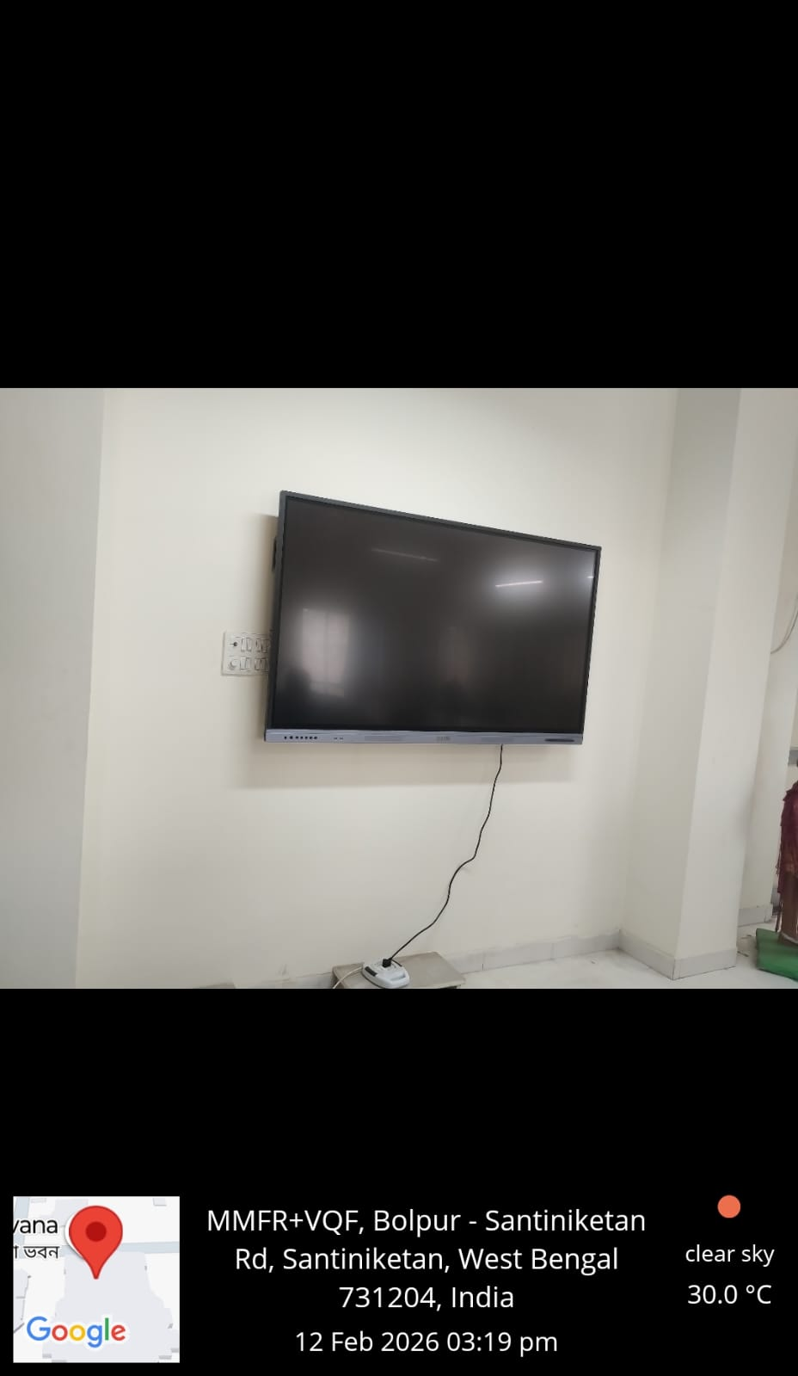
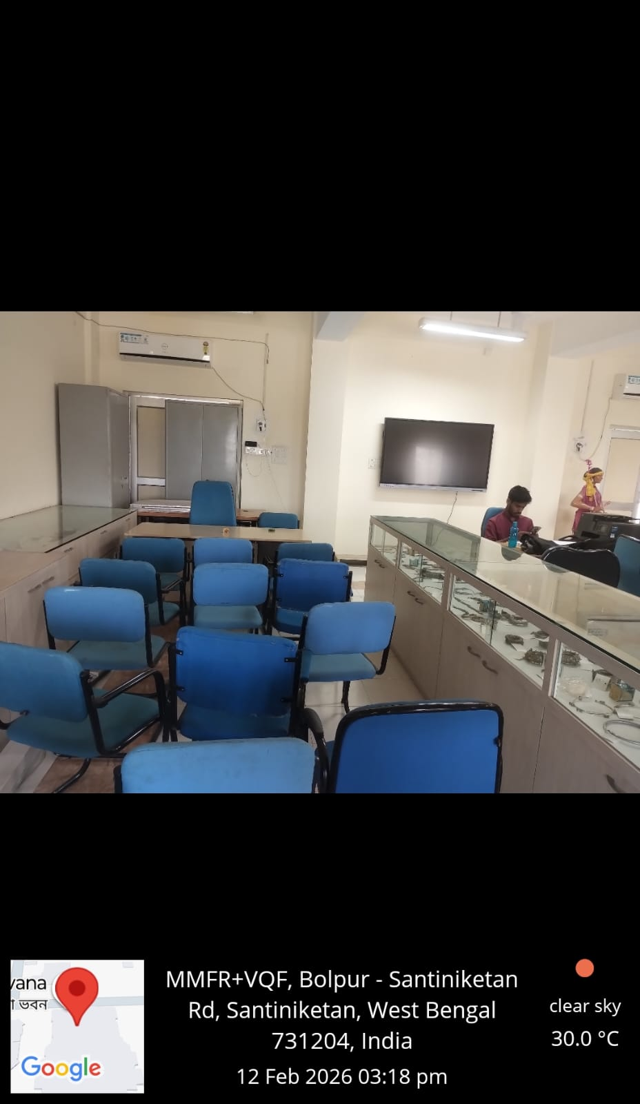

DEPARTMENT OF ODIA, VISVA-BHARATI
SANTINIKETAN – 731 235 (WEST-BENGAL)

Museum Arti facts
A distinctive academic asset of the Department is its Tribal–Folk Museum, housing rare artefacts representing the indigenous cultures of Odisha, West Bengal, and Jharkhand. The Department has sustained a vibrant tradition of scholarly engagement with tribal language and cultural communities across Odisha. In recognition of its significant academic contribution in this domain, the Department has been conferred the status of Centre of Excellence by the Ministry of Tribal Affairs, Government of India.
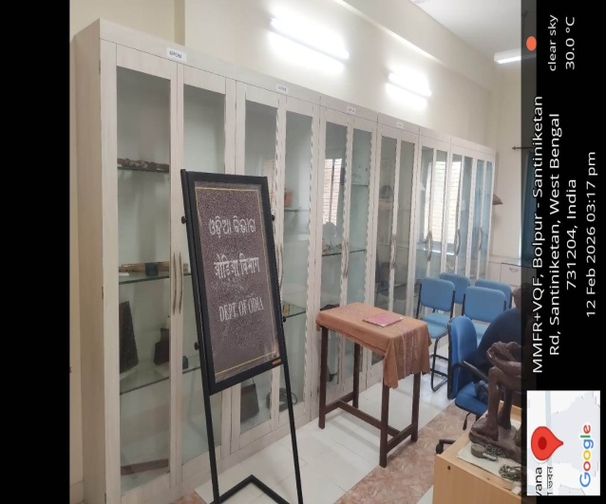
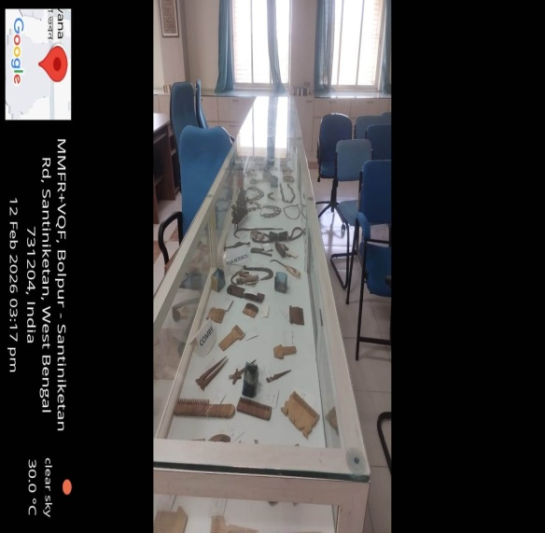

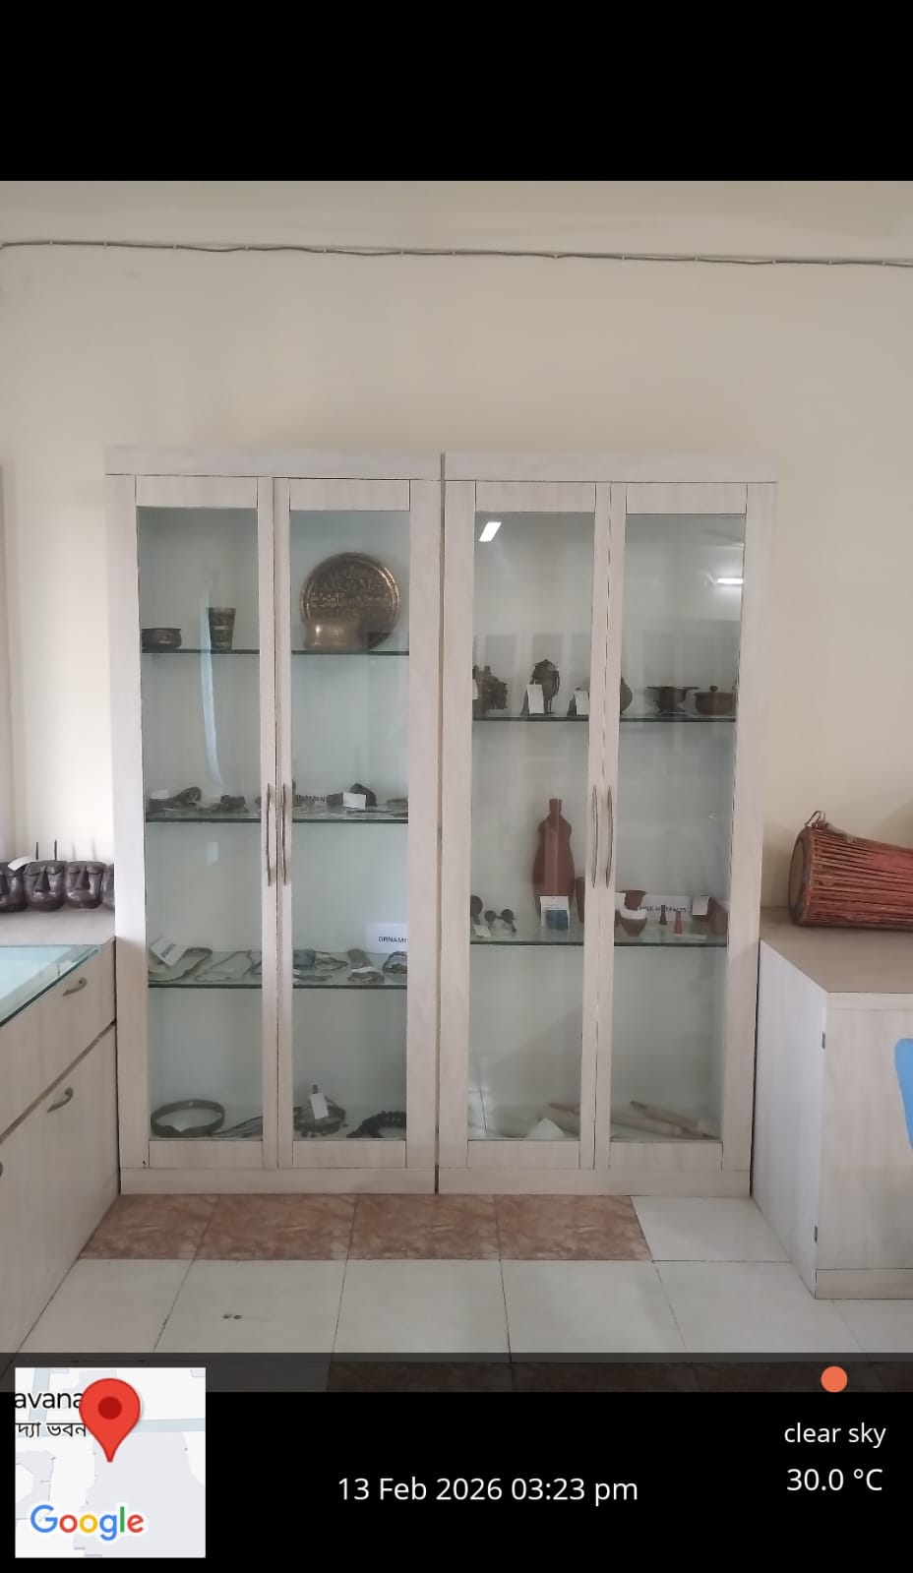
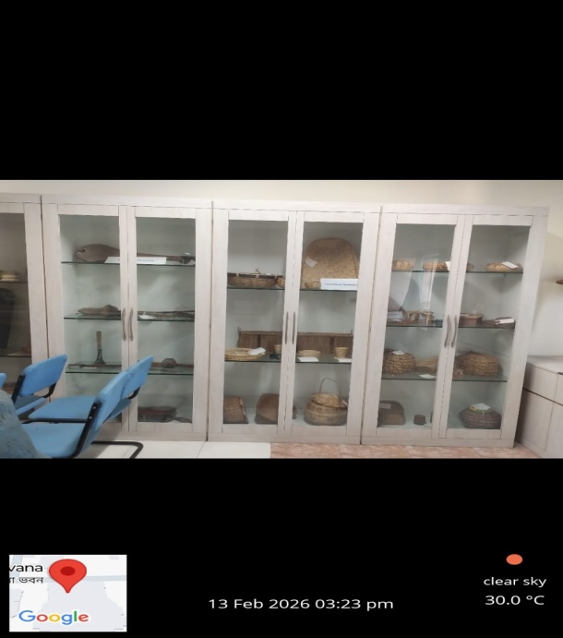

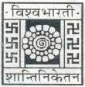
DEPARTMENT OF ODIA, VISVA-BHARATI
SANTINIKETAN – 731 235 (WEST-BENGAL)

Potable Drinking Water Facilities
The Department further ensures essential amenities, including a dedicated water purification system for students, research scholars, and faculty members.

